

ERD Main Tables– GRP01
Analyze the Cause and Effects of
Crimes in Austin, Texas

Course Information
Course Title Data Warehousing and Business Intelligence
Course Number INFO 7290-01 - 16977
Term and Year Fall 2020

Members
Gaurav Manicketh
Lekha Cheruku
Nitish Deshpande
Pragya Singh

ER Model – Main Tables (Facts and Dimensions)
Crime Dataset
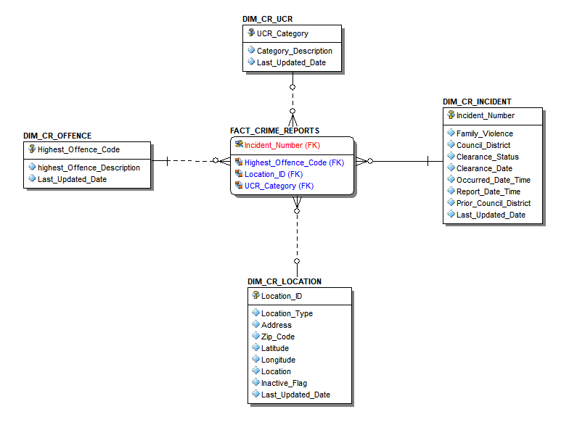
Unemployment Dataset
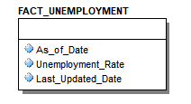
Latitude and Longitude Dataset
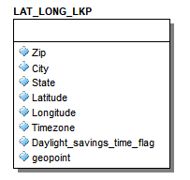
Camera Dataset
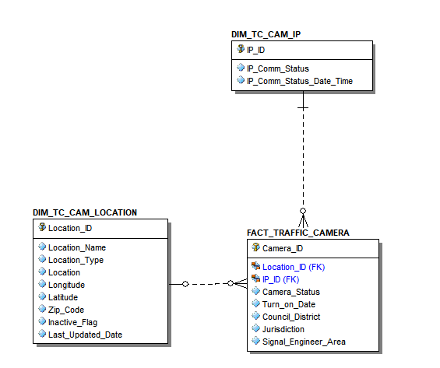
Bike Dataset
